Fig. . Plot of first peak current (ip) versus square root of sweep rates for

the electro reduction of (E)-1-(Furan-2-yl)-3-phenylprop-2-ene-1-ones

[10mM] in tetra butyl ammonium tetrafluoro borate.

Solvent = acetonitrile

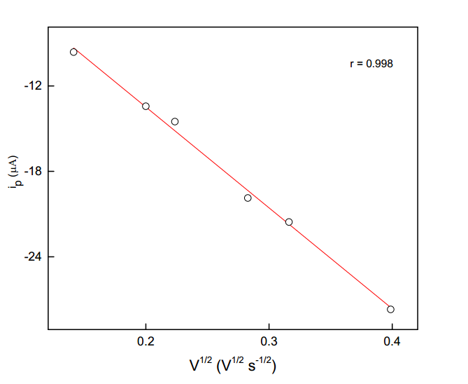

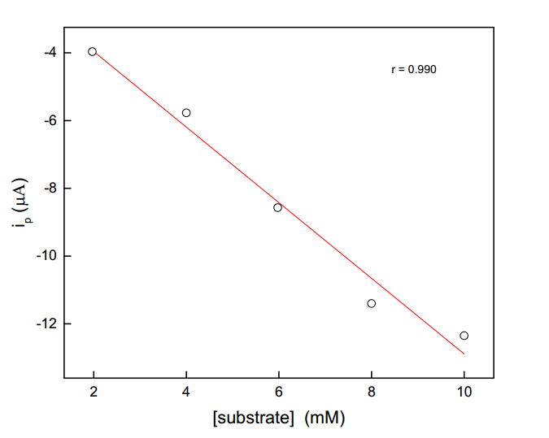

Fig. Plot of first peak current (ip) versus concentration of the

(E)-1-(Furan-2-yl)-3-phenylprop-2-ene-1-ones in tetra butyl

ammonium tetrafluoro borate.

Solvent = acetonitrile; Sweep rate 40 mV/s

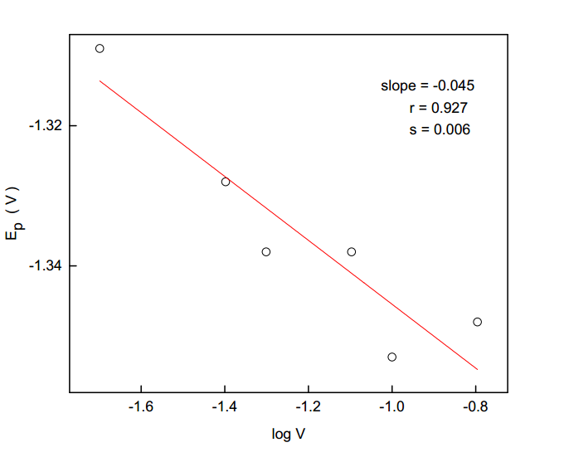

Fig. . Plot of first peak current (ip) versus log V for the electro

reduction of (E)-1-(Furan-2-yl)-3-phenylprop-2-ene-1-ones

[10mM] in tetra butyl ammonium tetrafluoro borate.

Solvent = acetonitrile